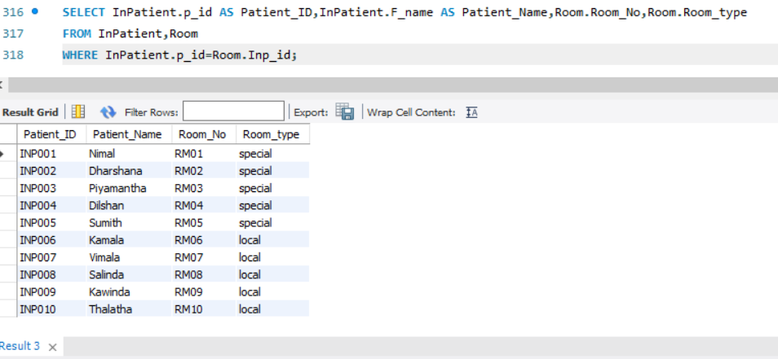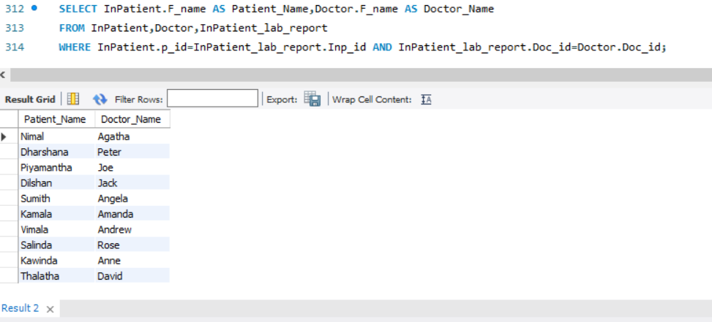Retrieve Inpatient names and their doctor names.

Retrieve Inpatient ID, Inpatient name and their Room number and room type

Creating new database using user “Patients@localhost”

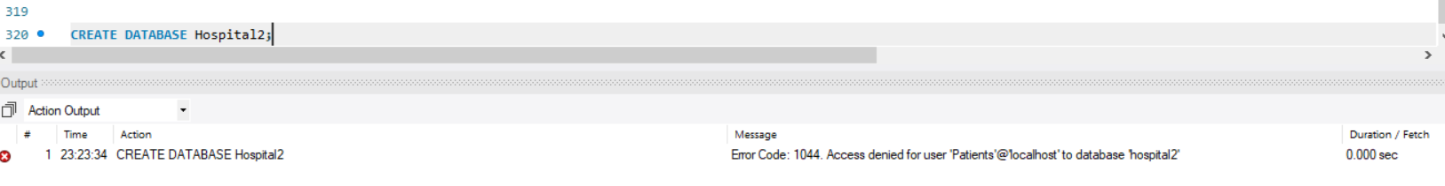

Calculate Inpatient Age from Inpatient DOB

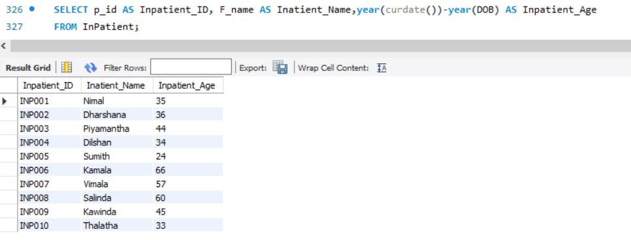

Retrieve Inpatients who born in 1988-01-01 and 1989-12-31

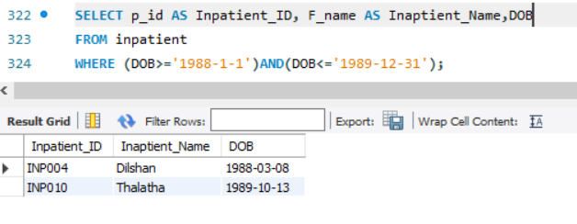

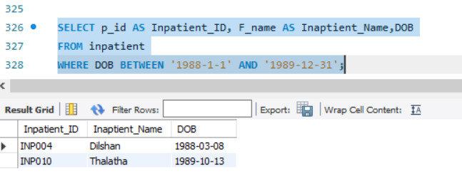

Update Address and Outpatient name of “OUTP001” in Outpatient Table and display the table

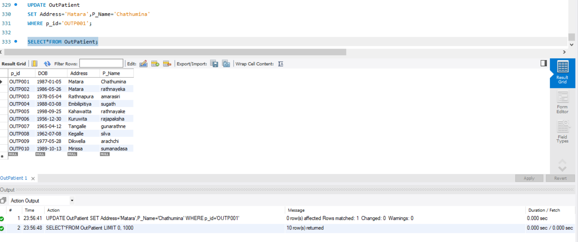

Add a new field named “Condition_” to Inpatient diseases table

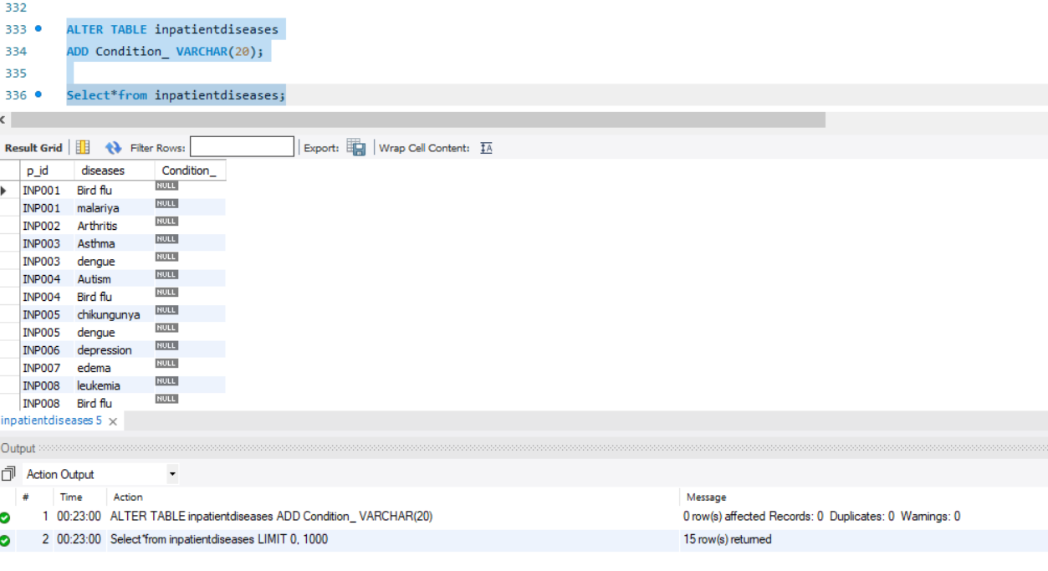

Display all the details from doctor table who has Surgery specialty.

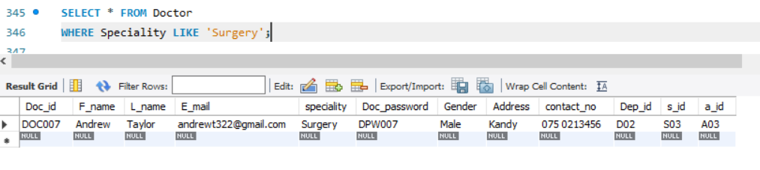

Retrieve Staff member ID, Staff member name, Salary of the 5 highest paid staff members from Staff table.

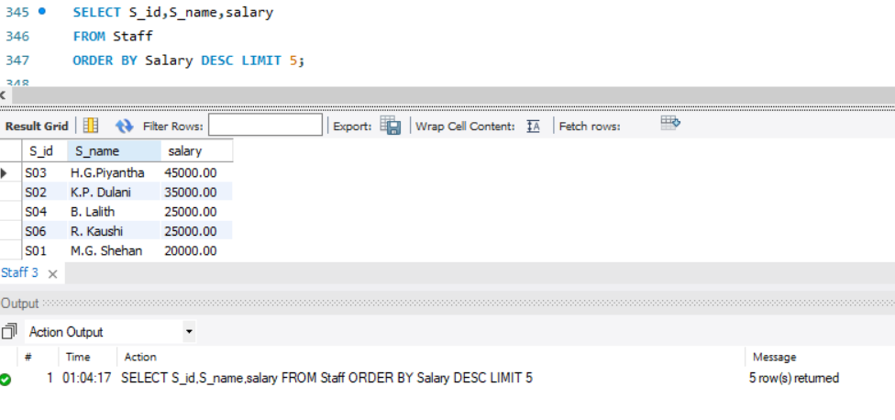

Delete details of Inpatient ID “INP010” from inpatientdiseases table.

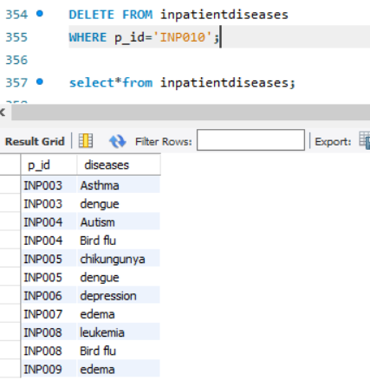

Insert a row into inpatientdiseases table.

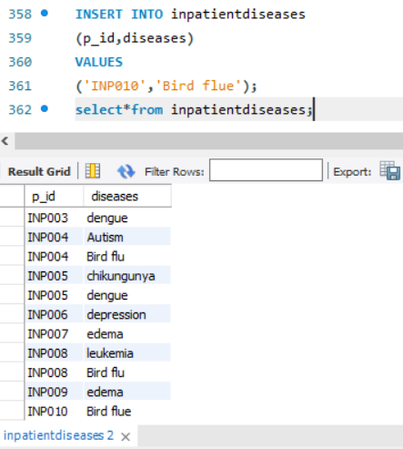

Retrieve number of doctors for each speciality.

